**Lesson Topic: Know Your Options**

**Objectives:**

* Discuss the benefits of abstinence
* List three methods of effective birth control
* Recall reasons other than pregnancy prevention for using birth control
* Explain effective condom use
* Apply existing laws relating to reproductive decision making
* Apply reproductive laws and legally available pregnancy options to situations involving an unplanned pregnancy

**Activities:**

Review (from lesson 2) the definition and benefits of abstinence.

Brainstorm why people may or may not want to use birth control.

Investigate birth control options.

Identify availability of birth control methods in the community

Examine a real-life scenario involving an unplanned pregnancy and recommend legal options based on reproductive rights for minors.

**Abstinence**

WCSD Definition

* + **Sexual Abstinence is defined as refraining from all forms of sexual activity and genital contact such as vaginal, oral and anal sex.**
  + **An abstinent person is someone who has either never had sex or someone who’s had sex but who has decided not to continue having sex for a period of time.**
  + **Abstinence is the only 100% effective way to prevent HIV, other sexually transmitted diseases or infections and pregnancy.** 
    - SEX-when a person’s genitals touch another person’s genitals, mouth or anus.

Slide 2:

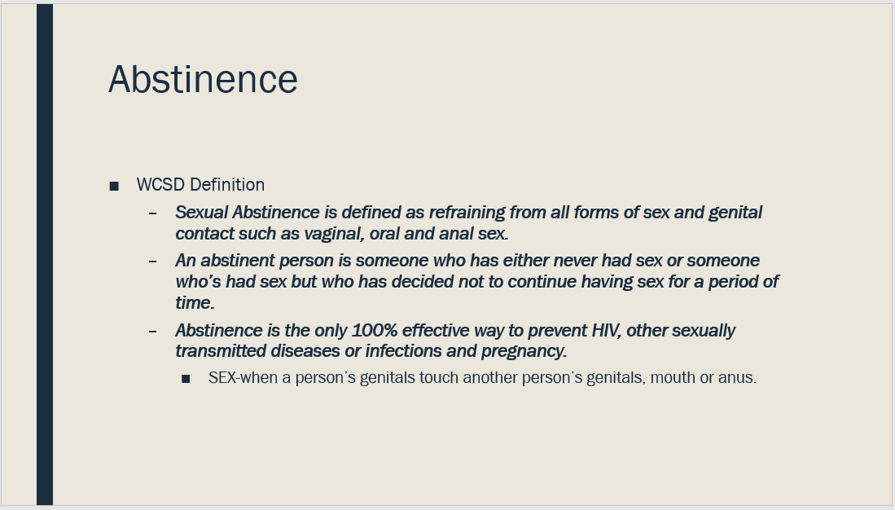

**Why someone may or may not choose to use birth control**

Today we are going to look at contraception or birth control such as abstinence, the pill condoms, the shot, etc.

What might affect a person’s decision to use birth control?

* to prevent pregnancy
* And/or for other reasons that have nothing to do with sex.

Brainstorm why a person might want to use birth control for either sexual or non-sexual reasons.

Write responses on board.

Possible responses:

* Don’t want to get pregnant
* Want to reduce acne
* Want to have shorter periods
* Want less cramping during periods
* Don’t want an STD
* Want to have predictable periods

Who do most of these apply to?

How do their partners come in to play, what rights and responsibilities do they have?

Which of these could apply to people in same-sex relationships?

There are many reasons why a person might choose to use contraception or birth control in addition to preventing pregnancy.

Brainstorm some of the factors that might impact whether a person/couple uses birth control.

Possible responses:

* Don’t have enough money
* Embarrassed to go to a pharmacy or clinic
* Don’t know what birth control methods are available
* Don’t have transportation
* Afraid parents/caregivers would find out

Slide 4:

**Complete which contraceptive is right for me activity –PowerPoint**

* Review contraceptive methods- Contraception at a Glance slide (click on compare all tab at the top of the webpage)

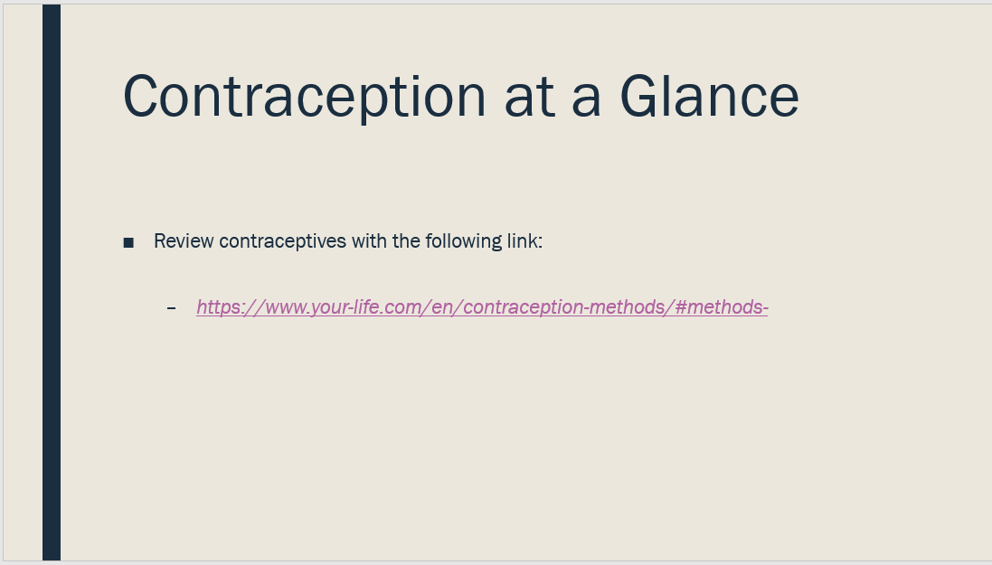

* Review the following scenarios and based on the information about each person, use the “Which Contraception is Right for Me” link to determine which contraceptive is appropriate for each scenario (choose 3).
  + - On second click of slide the “issue” will appear. It’s basically a wrench thrown into their thoughts on appropriate contraceptive ideas for each scenario.
  + This may be completed as whole or small groups.

<https://www.your-life.com/en/contraception-methods/which-contraception-is-right-for-me/>

Slide 5-7:

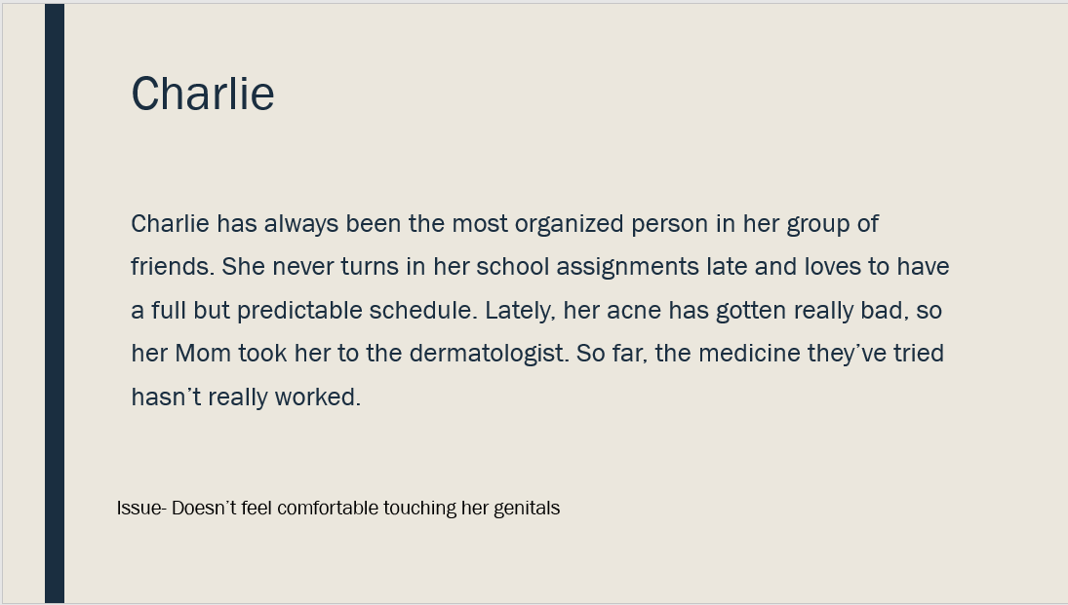

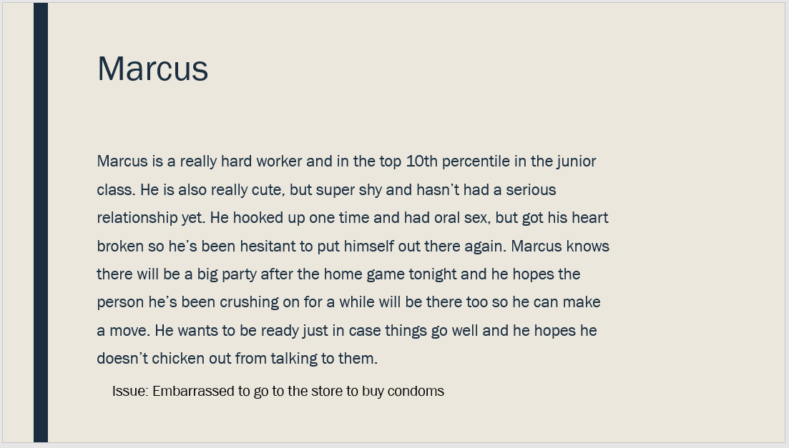

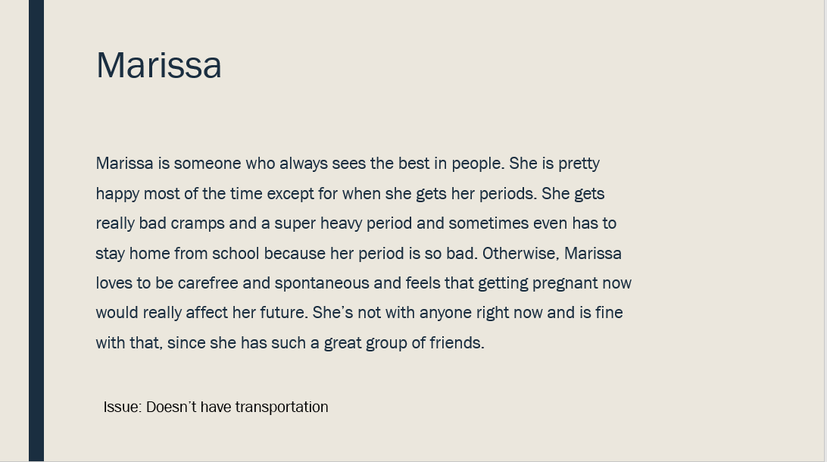

**Brainstorm places that contraceptives are available in the community**

* Washoe County District Health-Teen Health Mall
* Northern Nevada Hopes
* Community Health Alliance
* Planned Parenthood
* Doctors office/clinic
* Renown Women’s Health (formerly The Pregnancy Center)

Slide 8:

Where are contraceptives available?

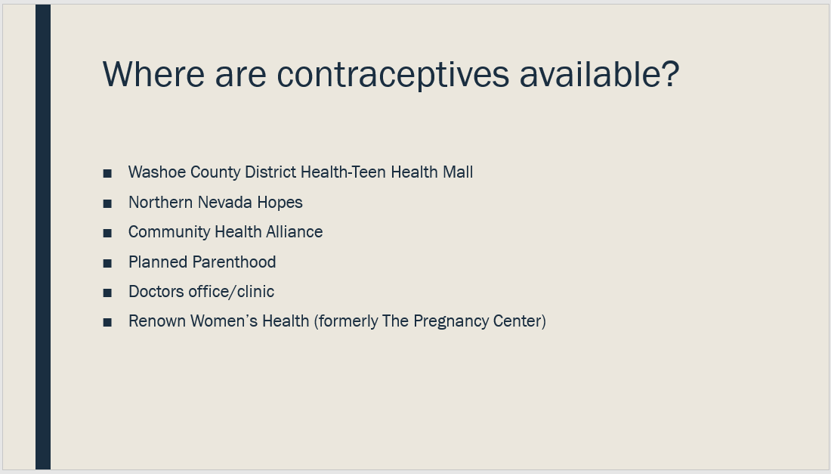

Slides 10-12:

**Effective condom use –PowerPoint**

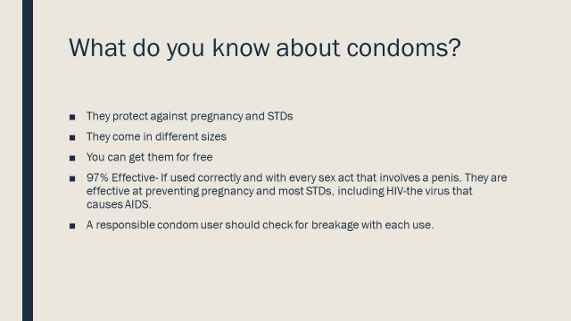

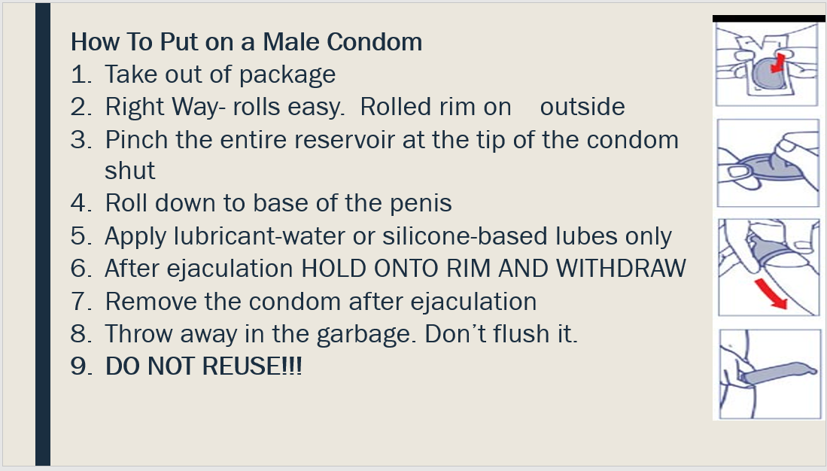

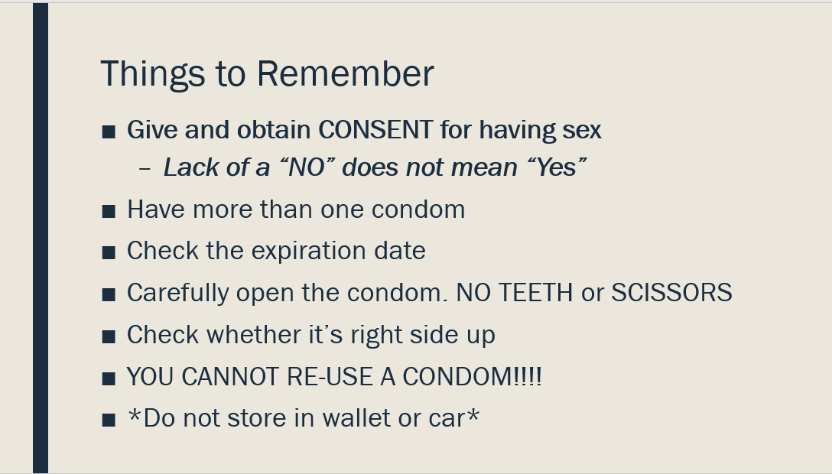

Slide 13: Always use a condom along with another form of birth control

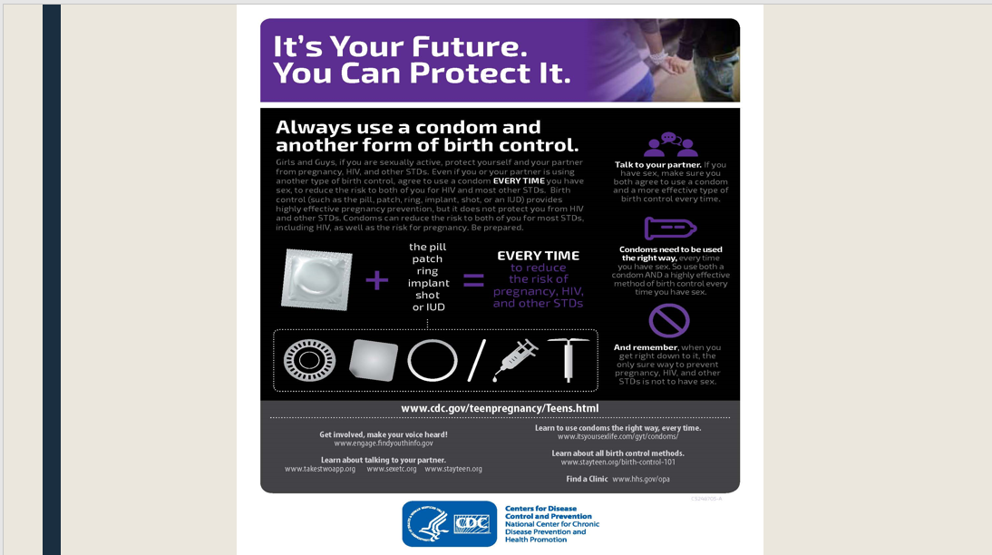

Slides 15-18:

**Examine a real-life scenario involving an unplanned pregnancy and recommend legal options based on reproductive rights for minors.**

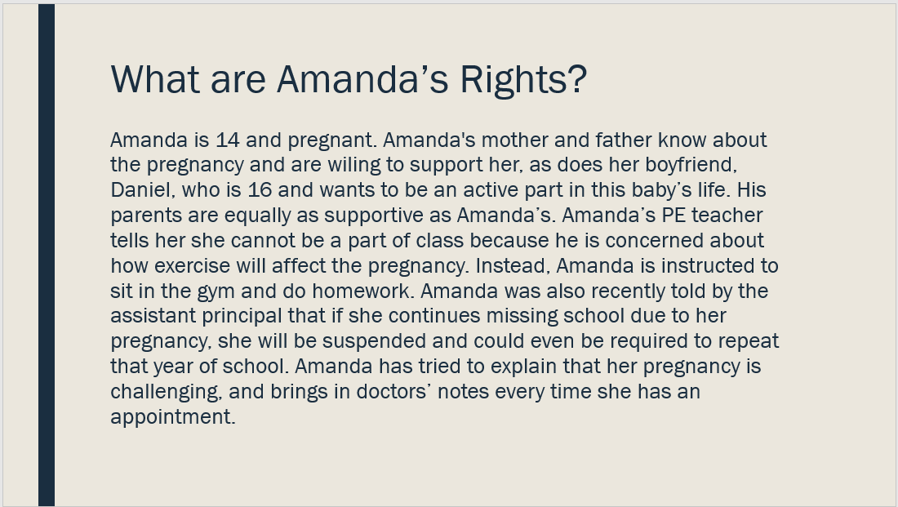

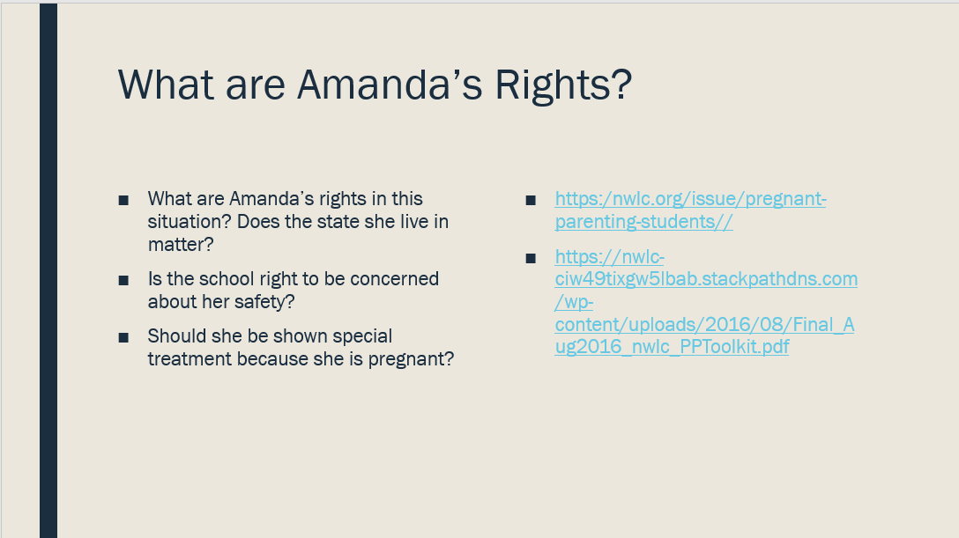

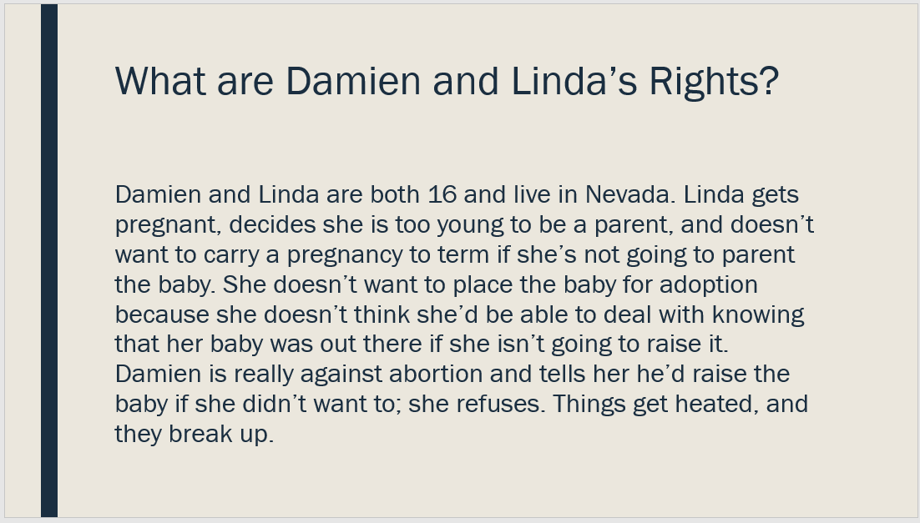

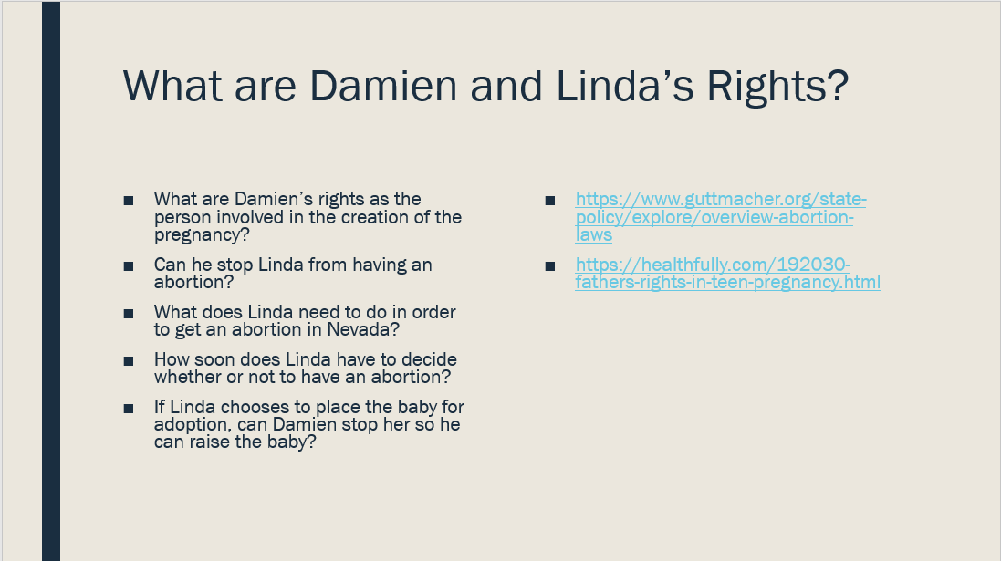

Slides 20-25:

**Facts About Teen Pregnancy Options…**

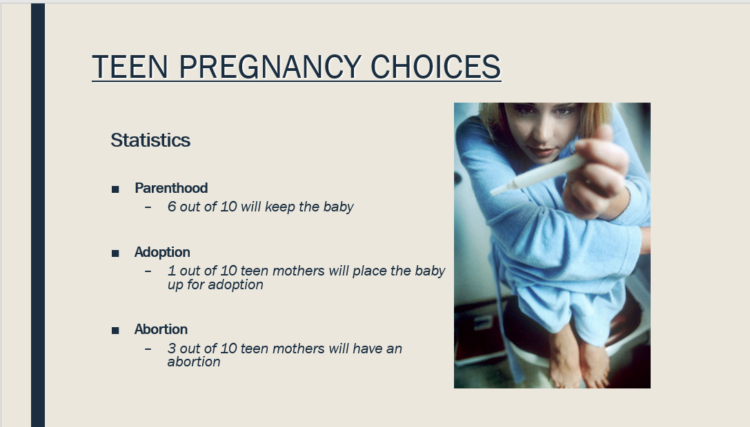

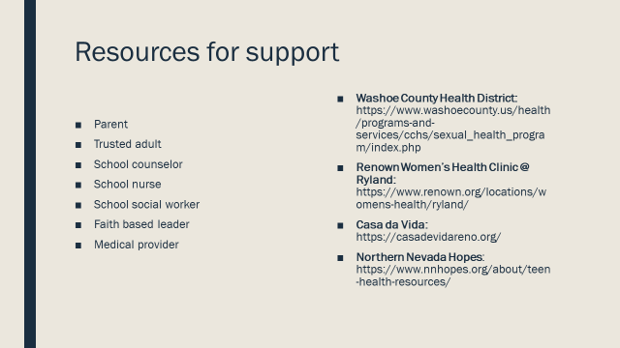

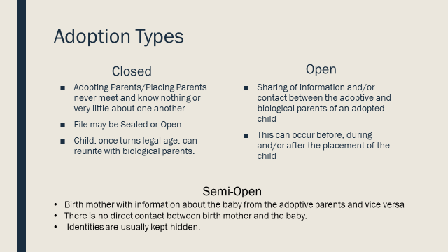

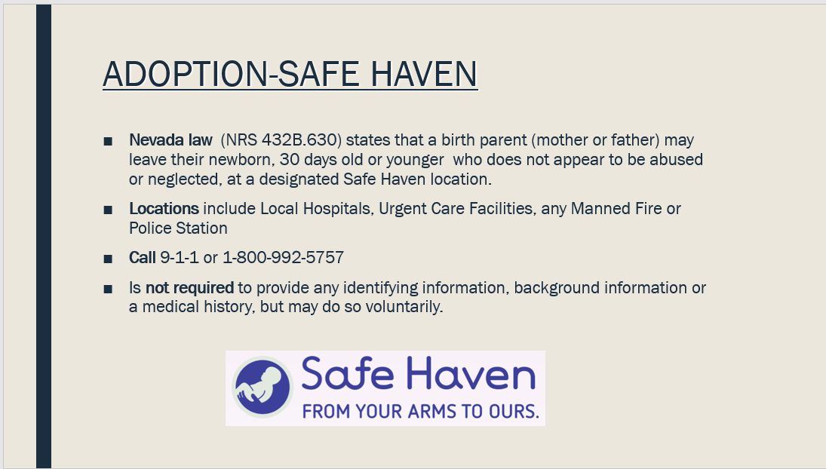

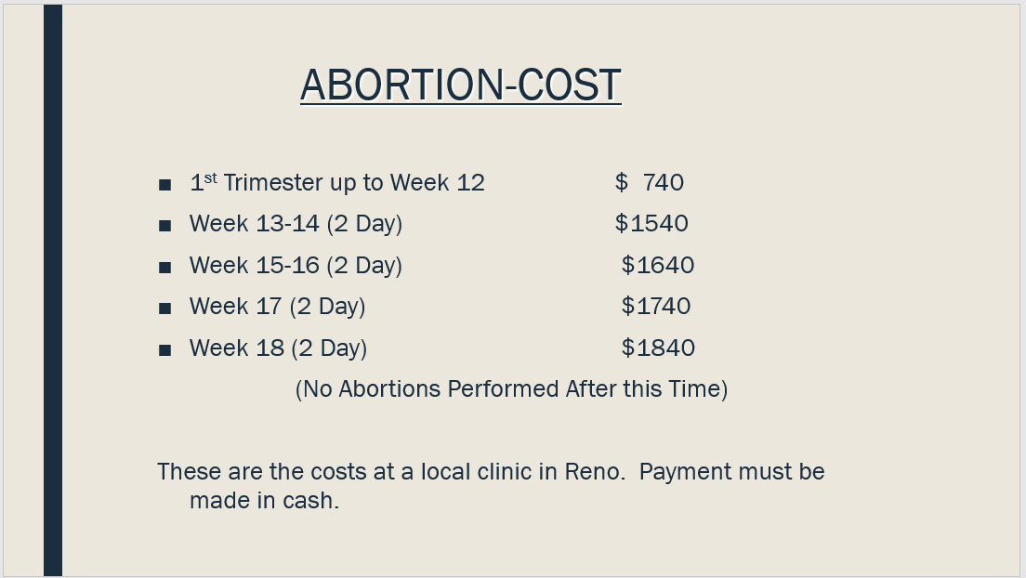

Slide 25: Make sure to review the difference between the Abortion Pill and Morning after Pill (the info is in the notes section of this slide)

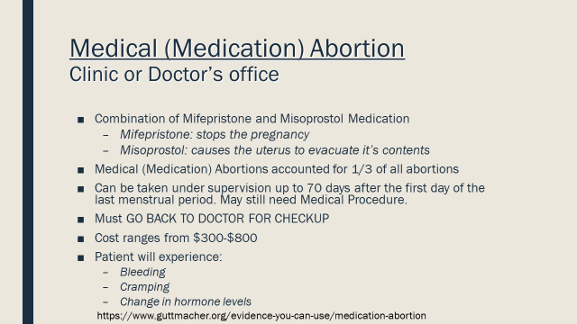

Slide 26: Remind students…talk to someone they trust.

